**SCREENSHOOT**

# PEMROGRAMAN WEB DAN MOBILE 1



|  |  |
| --- | --- |
| **NAMA :** | **A.IRWIN PUTRA PANGESTI** |
| **NIM :** | **223020503162** |
| **KELAS :** | **1 (AP 1)** |
| **MODUL :** | **II**  (**Form Handling)** |

**JURUSAN TEKNIK INFORMATIKA**

**FAKULTAS TEKNIK**

# UNIVERSITAS PALANGKA RAYA

**2024**

**LOGIN.PHP:**

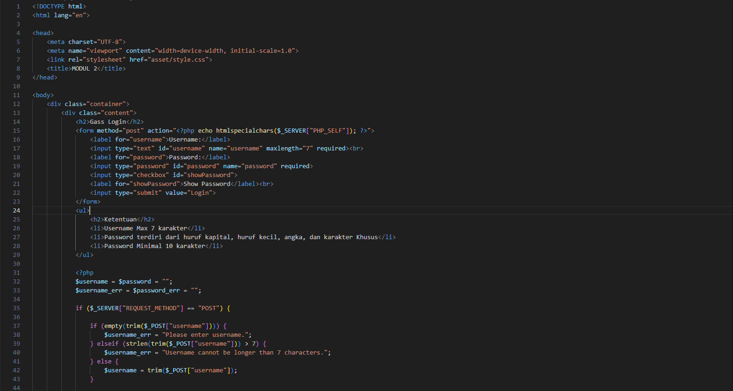

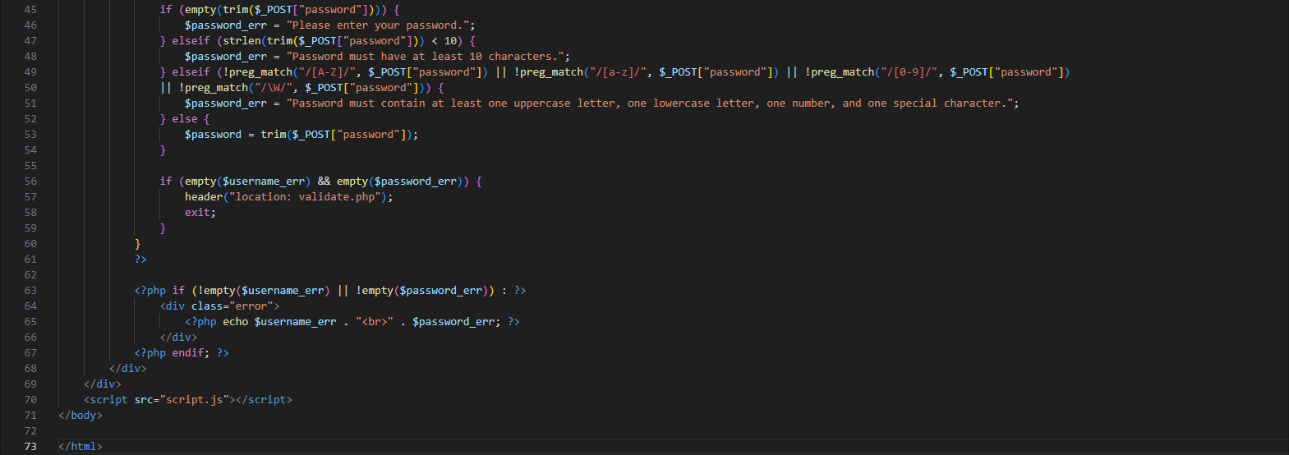

**VALIDATE.PHP:**

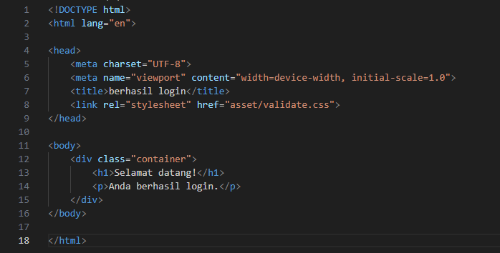

**STYLE.CSS:**

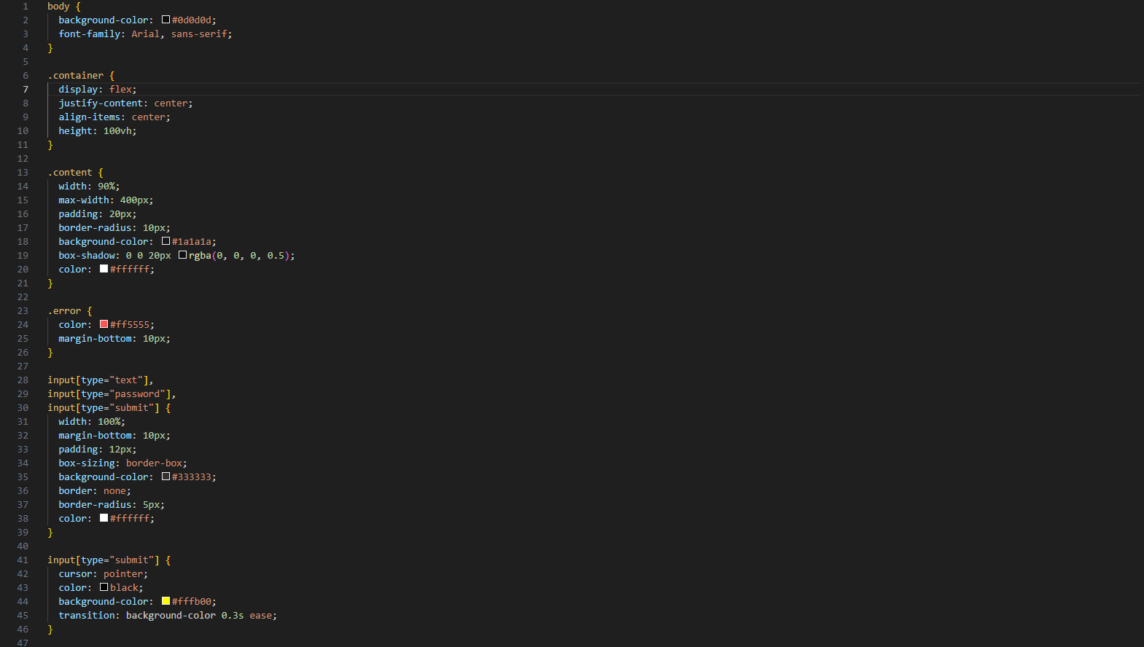

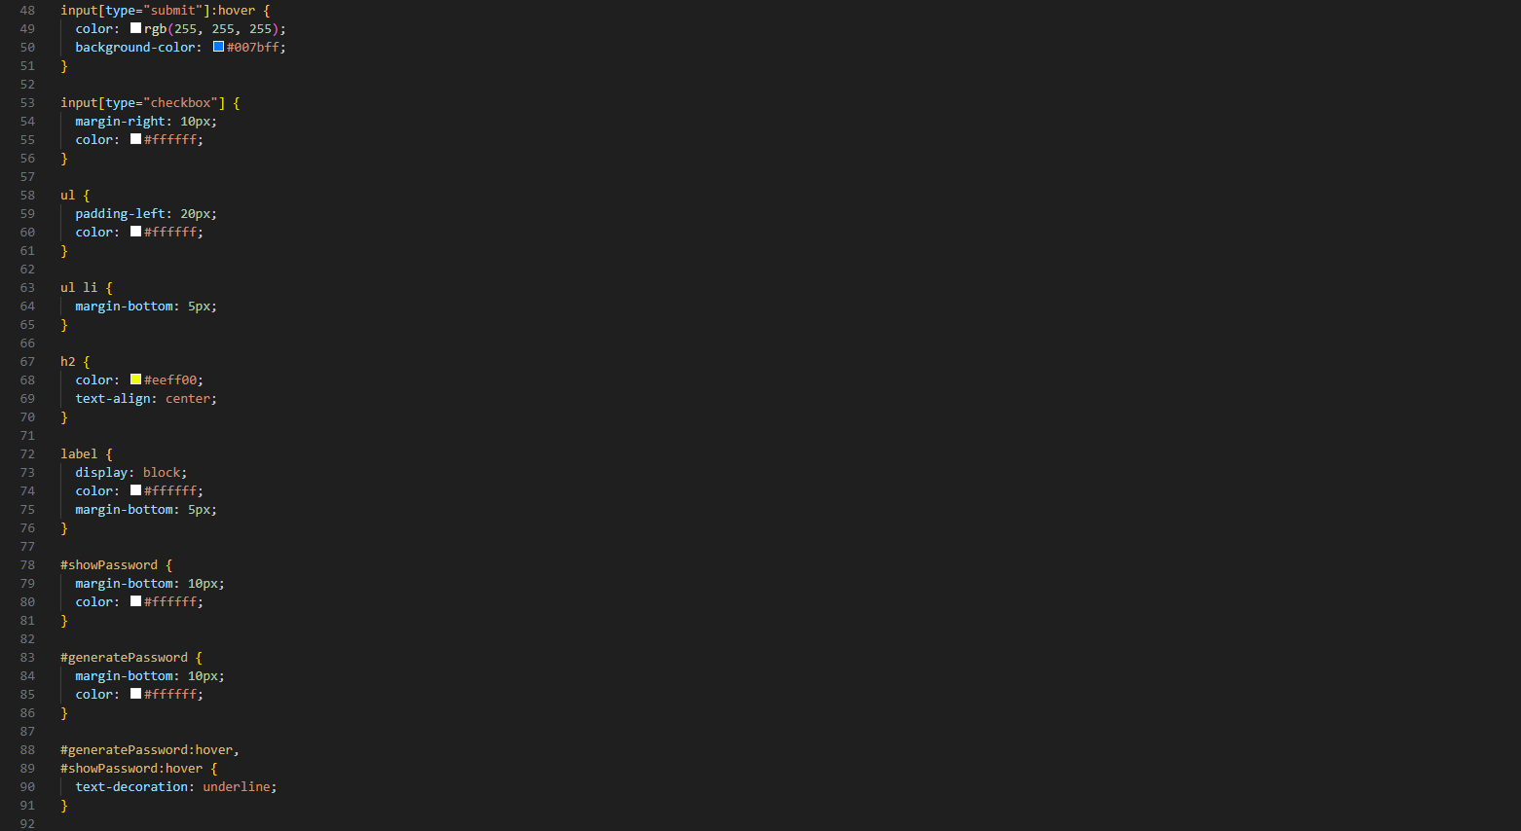

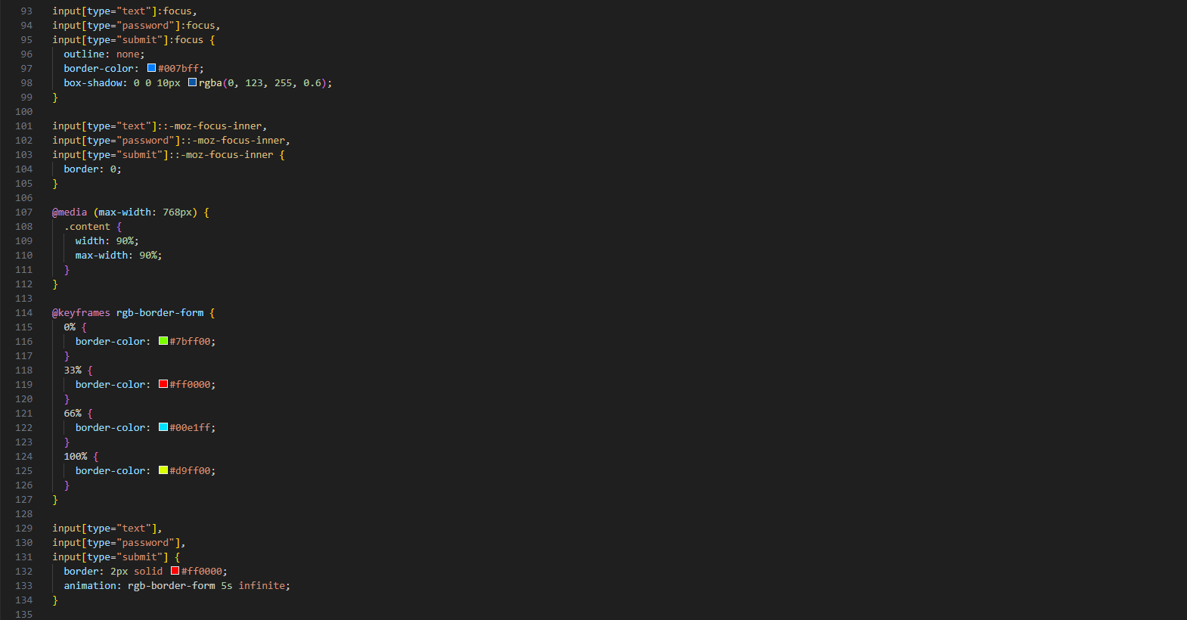

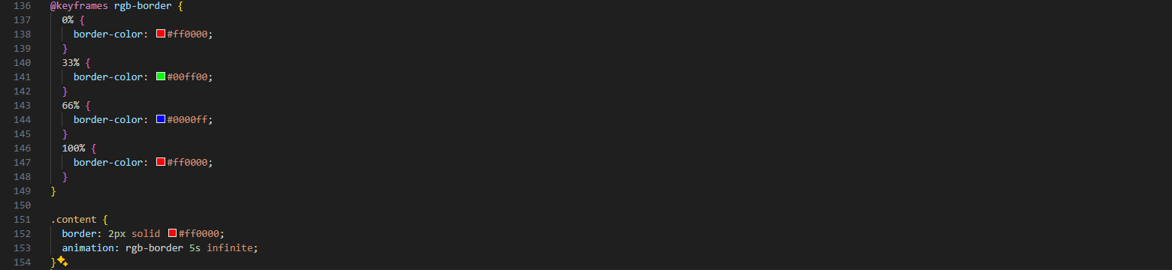

**VALIDATE.CSS:**

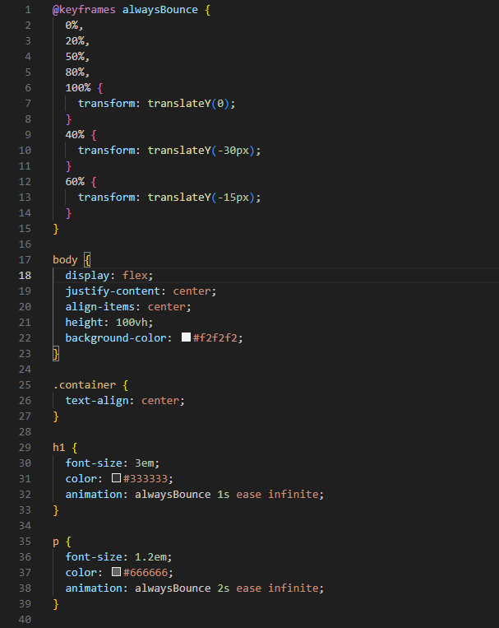

**SCRIPT.JS:**

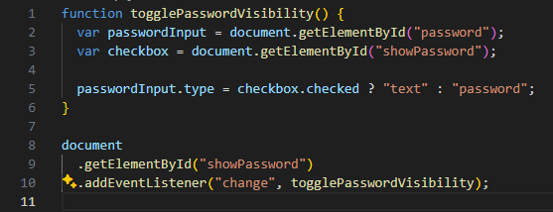

**OUTPUT LOGIN:**

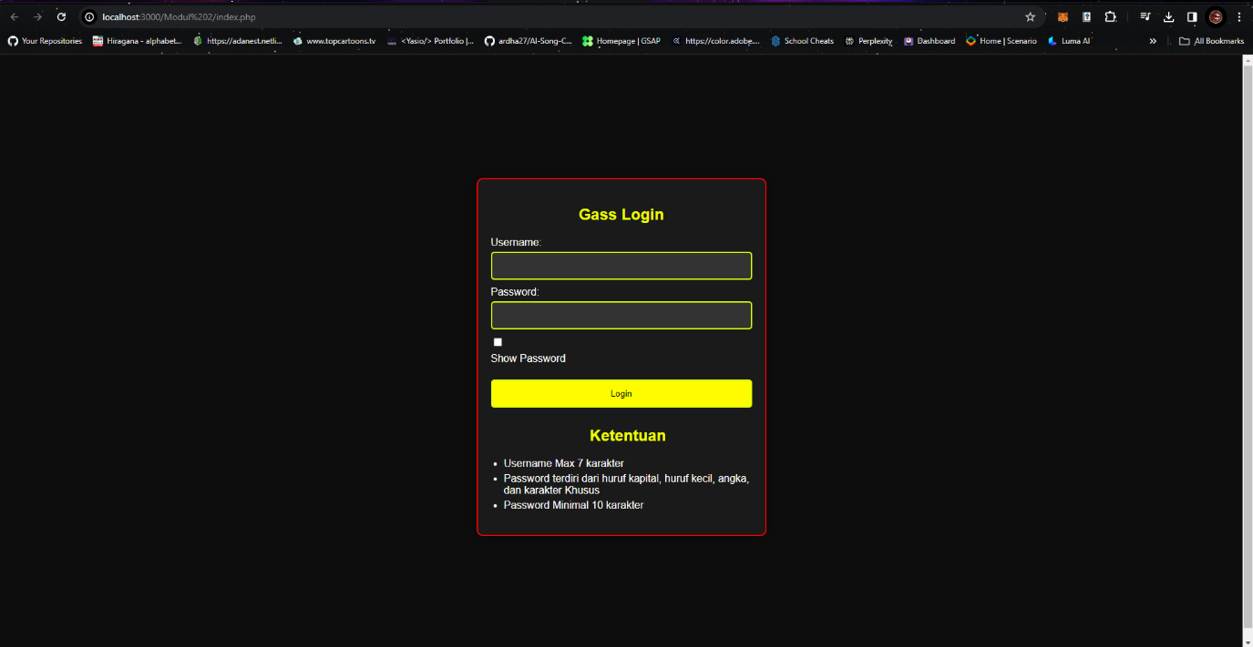

**OUTPUT VALIDATE:**

